MOVIE RECOMMENDATION SYSTEM
Dr. N. Sunanda  Department of Computer Science  and Engineering  Koneru Lakshmaiah Education  Foundation  Hyderabad, India | Tejaswi Chowdary  Department of Computer Science  and Engineering  Koneru Lakshmaiah Education  Foundation  Hyderabad, India  [2420030517] | Hasini Reddy  Department of Computer Science  and Engineering  Koneru Lakshmaiah Education  Foundation  Hyderabad, India  [2420030613] | Harshith Reddy  Department of Computer Science  and Engineering  Koneru Lakshmaiah Education  Foundation  Hyderabad, India  [2420030606]
Project Guide: Dr. N. Sunanda

Abstract— The Movie Recommendation System is a Data Science and Machine Learning project designed to help users discover movies according to their interests and preferences. The system analyzes movie characteristics such as genre, keywords, cast, director, and description and recommends movies that are similar to a movie selected by the user. The proposed approach follows Content-Based Filtering, in which recommendations are generated from the characteristics of the selected movie rather than from ratings or information supplied by other users. The movie dataset is first cleaned and pre-processed, after which relevant textual attributes are combined to form a meaningful movie representation. TF-IDF is used to transform textual information into numerical feature vectors, and Cosine Similarity is used to measure the similarity between movies. The movies with the highest similarity scores are ranked and returned as recommendations. A Streamlit-based interactive dashboard provides a simple interface through which a user can select a movie and view the resulting recommendations. The project demonstrates the practical application of data preprocessing, Natural Language Processing, feature extraction, similarity measurement, and Machine Learning in a real-world recommendation task.
Keywords—Movie recommendation, Content-Based Filtering, TF-IDF, Cosine Similarity, Natural Language Processing, Machine Learning, Streamlit, Data Science
I. INTRODUCTION
The rapid growth of digital streaming platforms has made thousands of movies available to users, but the large number of choices also makes movie discovery difficult. A user may know the type of movie they enjoy but still spend considerable time searching through titles, genres, descriptions, and cast information. A recommendation system addresses this problem by reducing the search space and presenting items that are relevant to the characteristics of a user's current selection.
Movie recommendation approaches can be broadly divided into popularity-based, content-based, collaborative, and hybrid methods. Popularity-based systems recommend movies that are highly rated or frequently watched. Collaborative filtering learns from interactions between users and items, while hybrid systems combine multiple recommendation strategies. Content-Based Filtering instead compares item characteristics and is particularly suitable when meaningful metadata such as genre, keywords, cast, director, and description is available.
The proposed project develops a content-based Movie Recommendation System using Data Science, Natural Language Processing, and Machine Learning techniques. The system represents each movie through selected textual attributes, converts those attributes into TF-IDF vectors, calculates Cosine Similarity between movies, and ranks the most similar titles. The final recommendations are exposed through a Streamlit dashboard so that the user can select a movie and immediately view a ranked list of related movies.
The main objective is therefore not to predict a rating, but to identify movies whose available content is similar to the selected movie. This makes the system transparent at the feature level and avoids dependence on a large collection of user-rating histories.
II. LITERATURE REVIEW
Recommendation research has developed from simple popularity lists toward systems that model item content, user behavior, or both. Content-Based Recommender Systems represent items using descriptive features and recommend items that are similar to those previously selected or preferred by a user. Such approaches are useful when item metadata is available and when recommendations must be generated without relying on other users.
Lops et al. described the state of the art in Content-Based Recommender Systems and emphasized the importance of item representation, feature extraction, and similarity-based retrieval. Adomavicius and Tuzhilin presented a broader survey of recommender-system techniques and highlighted content-based, collaborative, and hybrid approaches. These studies provide the conceptual foundation for selecting a content-oriented method for the present movie recommendation task.
Collaborative filtering is another major recommendation paradigm. Koren et al. demonstrated the importance of latent-factor and matrix-factorization methods for learning relationships from user-item interactions. Such techniques can perform well when sufficient interaction data exists, but they are not required for the present project because the available movie information itself provides the basis for similarity calculation.
The textual component of the proposed system is supported by TF-IDF weighting. Salton and Buckley discussed term-weighting approaches for information retrieval, establishing the principle that terms should receive greater importance when they are informative within a document but less importance when they occur broadly across a collection. This principle is appropriate for transforming movie metadata into numerical representations.
The literature therefore indicates a clear role for content representation and similarity measurement in recommendation. The present project combines these ideas into an end-to-end workflow that begins with movie-data preparation and ends with ranked recommendations in an interactive dashboard.
A. Research Gap
Many recommender-system studies emphasize algorithmic performance or large-scale user-interaction data. For a student-scale movie recommendation application, a simpler and more interpretable workflow is useful: movie metadata can be cleaned, combined, converted into TF-IDF vectors, compared through Cosine Similarity, and presented through a lightweight interface. The project addresses this practical gap by integrating preprocessing, textual feature engineering, similarity-based ranking, and user-facing visualization in a single workflow.
III. PROPOSED METHODOLOGY
The proposed system follows a sequence of transformations from raw movie information to ranked recommendations. The major stages are data collection, preprocessing, feature selection, textual representation using TF-IDF, similarity calculation using Cosine Similarity, recommendation ranking, and Streamlit-based presentation.
A. Data Collection
The input consists of a movie dataset containing descriptive attributes such as movie title, genre, keywords, cast, director, and movie description. These fields provide the information required to represent a movie according to its content. The title is retained for identification and display, while the descriptive fields are used as the principal inputs to the recommendation model.
B. Data Preprocessing
The dataset is inspected for missing, unnecessary, or inconsistent values before model construction. Relevant text fields are cleaned and prepared so that they can be combined into a common representation. This stage is important because irrelevant or incomplete text can reduce the quality of the similarity calculation. The preprocessing stage produces a consistent movie-level record for subsequent feature extraction.
C. Feature Selection and Combination
The selected features are genre, keywords, cast, director, and description. These attributes capture different aspects of movie content: genre represents broad category, keywords capture themes and topics, cast and director provide creator-related information, and the description provides contextual information about the movie. The selected fields are combined into a single textual representation for each movie.
D. TF-IDF Feature Extraction
Term Frequency–Inverse Document Frequency (TF-IDF) converts the combined movie text into numerical feature vectors. Terms that occur frequently within a particular movie representation but are less common across the entire collection receive greater weight. The result is a vector-space representation in which movies can be compared mathematically.
E. Cosine Similarity
Cosine Similarity measures the angular similarity between two TF-IDF vectors. For vectors A and B, the similarity is defined as cos(A,B) = (A·B) / (||A|| ||B||). A value closer to one indicates greater similarity in the represented feature space, while a value closer to zero indicates weaker similarity. For a selected movie, the system calculates its similarity with the other movies and uses these scores to create the recommendation ranking.
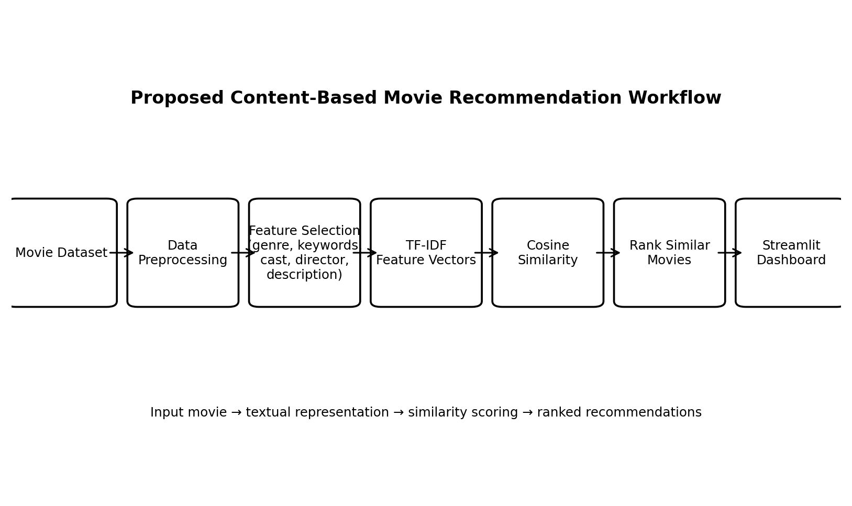
Fig. 1. Proposed content-based movie recommendation workflow.
F. Recommendation Ranking
After similarity scores are calculated, the system sorts the candidate movies in descending order of similarity. The highest-ranked titles are selected as recommendations. The selected movie itself is excluded from the returned list so that the output contains alternative movies rather than repeating the user's input.
G. Interactive Dashboard
A Streamlit dashboard provides the user interface. The user selects a movie from the available titles, after which the system retrieves the corresponding feature vector, calculates similarity scores, ranks the candidate movies, and displays the recommended titles. This separates the machine-learning workflow from the presentation layer and makes the system accessible without requiring the user to execute model operations manually.
IV. SYSTEM IMPLEMENTATION
The implementation uses Python together with Pandas and NumPy for data handling and Scikit-learn for TF-IDF vectorization and Cosine Similarity. The movie dataset is loaded into a structured data frame, the selected text attributes are prepared and combined, and the resulting text is transformed into a TF-IDF matrix. A similarity matrix is then derived from the vector representation. When a user selects a movie, the system locates its index, retrieves the corresponding similarity scores, sorts the scores, and returns the most similar titles.
The overall workflow can be summarized as: Movie Dataset → Data Preprocessing → Feature Selection → TF-IDF Feature Vectors → Cosine Similarity → Similarity Ranking → Streamlit Dashboard. This workflow keeps the recommendation logic deterministic and directly tied to the movie attributes contained in the dataset.
V. RESULTS AND OUTCOMES
The implemented design produces a ranked list of movies for a selected input movie. The recommendation logic is based on similarity in the combined textual feature space, so movies sharing important genre, keyword, cast, director, or description terms can receive higher similarity scores. The output is therefore a content-based ranking rather than a rating prediction.
The project outcome includes a cleaned movie dataset, a TF-IDF representation of movie content, a Cosine Similarity-based recommendation mechanism, and an interactive Streamlit interface. The supplied project material defines the expected outcome as a ranked list of similar movies and a dashboard through which users can select a movie and view recommendations. No quantitative accuracy, precision, recall, or user-study measurements were supplied in the project documents; therefore, the present paper does not claim numerical performance values.
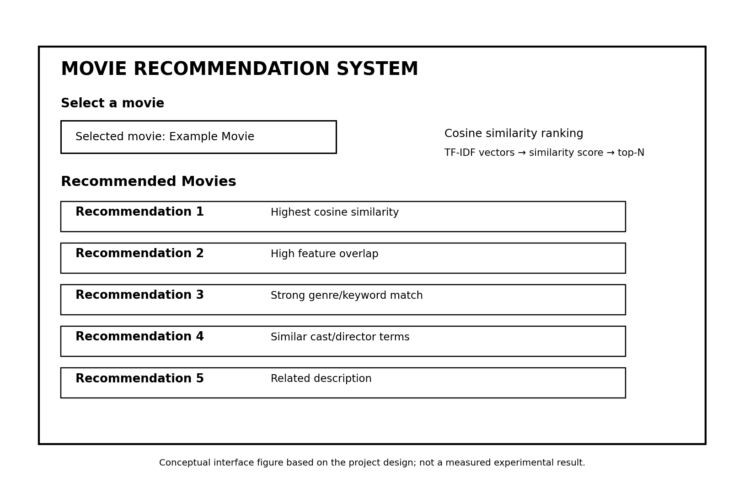
Fig. 2. Conceptual Streamlit interface for selecting a movie and viewing ranked recommendations.
A. Functional Findings
The system demonstrates that a movie can be represented using descriptive metadata and compared with other movies without requiring information from other users. TF-IDF provides the numerical representation needed for similarity computation, while Cosine Similarity provides a direct measure for ranking candidate movies. The dashboard converts this computational output into an interaction in which the user selects a title and receives a recommendation list.
B. Limitations
The content-based approach depends on the quality and completeness of movie metadata. If descriptions or keywords are missing, the resulting representation may not capture the full characteristics of a movie. The system also does not learn from individual user behavior, ratings, watch history, or feedback. Consequently, two users selecting the same movie will receive the same content-based ranking unless additional personalization mechanisms are introduced.
VI. CONCLUSION
The Movie Recommendation System provides an end-to-end application of Data Science, Natural Language Processing, and Machine Learning for movie discovery. The proposed workflow cleans and prepares movie metadata, selects relevant descriptive features, transforms the combined text using TF-IDF, measures movie-to-movie similarity using Cosine Similarity, and presents the highest-ranked alternatives through a Streamlit dashboard.
The main contribution of the project is the integration of these stages into a simple and interpretable content-based recommendation workflow. Because the recommendations are derived from movie characteristics, the system can operate without a user-rating database. The resulting application reduces the effort required to search through a large movie collection and demonstrates how textual feature engineering can support a practical recommendation task.
VII. FUTURE SCOPE
The system can be extended by incorporating collaborative filtering so that user ratings, watch history, and interaction patterns can contribute to recommendations. A hybrid model could combine content similarity with collaborative signals to improve personalization and reduce limitations associated with metadata alone.
Further improvements can include richer metadata, movie posters, multilingual descriptions, user profiles, feedback-based ranking, and evaluation using standard recommendation metrics such as Precision@K, Recall@K, F1@K, Mean Average Precision, or NDCG. These extensions would allow the current content-based prototype to be evaluated more systematically and developed into a more personalized recommendation platform.
VIII. REFERENCES
[1] G. Adomavicius and A. Tuzhilin, “Toward the Next Generation of Recommender Systems: A Survey of the State-of-the-Art and Possible Extensions,” IEEE Transactions on Knowledge and Data Engineering, vol. 17, no. 6, pp. 734–749, 2005.
[2] P. Lops, M. de Gemmis, and G. Semeraro, “Content-Based Recommender Systems: State of the Art and Trends,” in Recommender Systems Handbook, Springer, pp. 73–105, 2011.
[3] G. Salton and C. Buckley, “Term-Weighting Approaches in Automatic Text Retrieval,” Information Processing & Management, vol. 24, no. 5, pp. 513–523, 1988.
[4] Y. Koren, Y. Bell, and C. Volinsky, “Matrix Factorization Techniques for Recommender Systems,” Computer, vol. 42, no. 8, pp. 30–37, 2009.
[5] F. Ricci, L. Rokach, and B. Shapira, Eds., Recommender Systems Handbook, 3rd ed., Springer, 2022.

